**Prepare Lab Sheet of MYSQL Statements for following.**

1. Write a stored procedure named “GetEmployee()” to get name, birthdate, address of employees.

1. Execute the procedure in Q.1 and show the result.

1. Write a stored procedure to get PF category name, Amount and start date where the amount is greater than provided input value. Your procedure should contain an IN parameter named amt to take input value of amount. Call the procedure with inputs 1000 and 3000 respectively.

1. Write a stored procedure to get number of PF records where the amount of PF is equal to the provided input value. Your procedure should contain an IN parameter named amt to take input value of amount and should contain OUT parameter named total to return the total number of PF records satisfying the condition.

1. Call the procedure in Q4. with input of 3000 and print the @total.

1. Write before insert trigger before inserting a record into the Employee table. Show some action on the event.

**Before insert** trigger created so that if salary is inserted negative value, it set the salary value to 0.

Here, Suresh timalsina’s salary is inserted as -55000 but after the trigger is trigged the value is set to zero.

1. Write after delete trigger on PF table during delete operation. Print “It is deleted”.

First create a table to store the deleted items

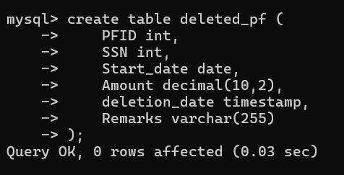

Created **after delete** trigger to insert the deleted item in the newly created table.

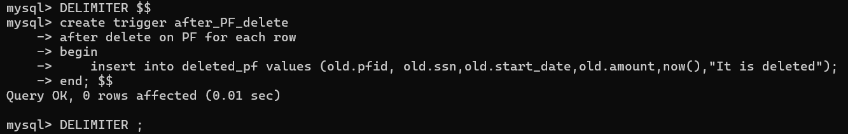

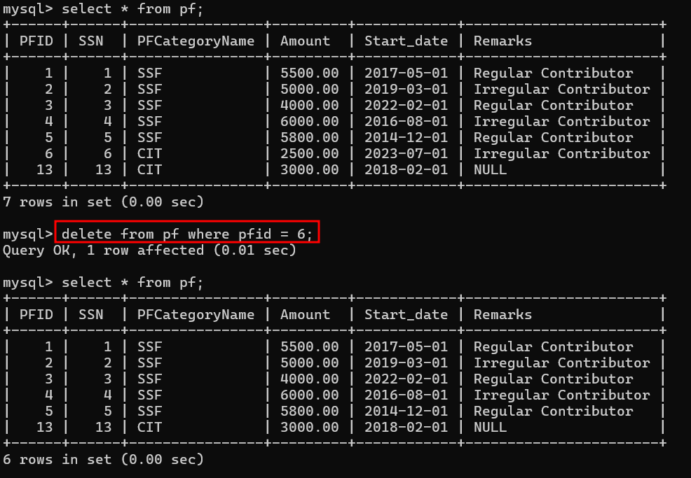

Delete event triggered

**After Delete** trigger, the deleted item is inserted into newly created database with message “It is deleted”.